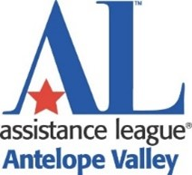 MEMBERSHIP RENEWAL FORM

It’s time to renew your membership for 2024-2025 Fiscal Year.

Making a positive difference in the lives of the children and their families of our community through our service programs.

With your renewal completed we can get started on:

LEARN – Develop skills and talents you never knew you had!

MEET – Make new friends and lifetime relationships!

HELP – Realize that a single drop of hope can make a change!

PARTICIPATE – In Fundraisers and Programs!

CONTINUE – To receive current information from our Chapter!

KNOW – You are a vital part of Assistance League! We need you!

NEVER FORGET THE DIFFERENCE YOU MAKE!

Please consider the correct classification for your membership choice:

Voting members are expected to attend monthly meetings to ensure we have a quorum for voting on business matters.
Non-Voting members are encouraged to continue to participate in meeting and programs as much as possible.

Name:____________________________________________________
Address:__________________________________________________
Phone:_________________ Email:____________________________

Please indicate Voting or Non-Voting

____________ Voting $50.00 __________Non-Voting $65.00

Questions? Please contact Linda Broderius at 661-236-4180

